Website Request & Planning Template
Thank you for taking the time to fill out this form. Your detailed answers will help me understand your vision, goals, and needs, ensuring I build a website that perfectly aligns with your objectives. Please be as specific as possible.

Section 1: Basic Information
- Client/Company Name: Gombian Boutique
- Contact Person & Title: Christian Gomba Founder
- Email: christian@gombianboutique.co.za
- Phone: 0843429374
- Preferred Communication Method: email & phone

Section 2: Project Overview & Purpose
- What is the primary purpose of this website? generate leads, share information/portfolio

- What are the top 3 goals you want this website to achieve?

  - Get 50 contact form submissions per month
  - Establish credibility
  - Customer engagement

- What is your unique value proposition? Our brand is unique and we specialize in customer experience over just making a sale of our products.
- Do you have an existing website? No

Section 3: Target Audience
- Who is your primary target audience? People who have a taste for luxury and high quality brands

- What are the main needs or problems of your audience that this website will address?
Brand exposure and accessibility.

- What action do you want visitors to take? Call us, Download a catalogue, and Sign up for a newsletter.

Section 4: Content & Pages
- What specific pages do you envision on the main menu? Home, About Us, Portfolio/Gallery, Blog/News, Contact.

- Do you have existing content? (Text, logos, photos, videos, brand guidelines). If yes, please describe what you have ready. I have submitted them.

- Will you need copywriting (text content) or photography services? No, I have provided them.

- Please list any key messages, slogans, or mandatory information that must be included.
Our slogan is “Elegance Unmatched”

Section 5: Design & Style
- Do you have existing brand colors, fonts, or a logo?
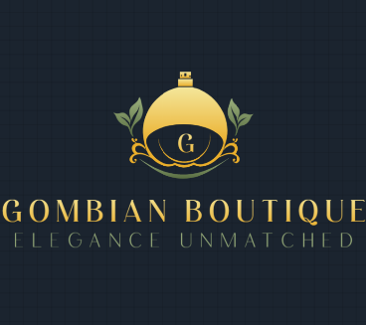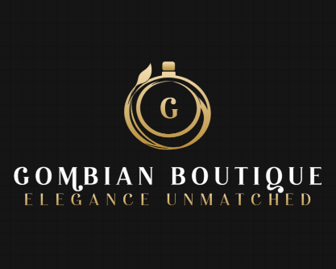
- Share 2-3 websites you like the look/feel of and briefly explain why. (e.g., "I like the clean layout of [example.com]," "The bold colors on [example.com] are appealing").
  - Accents of luxury colours, gold, red and black.
  - I would like you to be as creative and unique as possible, no limitations.

- Describe the desired tone or personality of the site. Professional, Modern & Creative, Luxurious & Elegant.

- Are there any specific design elements you strongly dislike? No

Section 6: Functionality & Features
Please check any features you know you'll need:
- E-commerce (Online store with shopping cart & payment processing) For Future
- Contact Forms (Basic, multi-step, file upload)
- Blog / News Section
- Photo or Video Gallery
- Member Login / User Accounts
- Social Media Integration / Feeds
- Newsletter Signup (Integration with Mailchimp, etc.)
- Multilingual Support

Section 7: Technical & Administrative
- Do you already have a domain name? (e.g., www.yourbusiness.com) If yes, what is it? www.gombianboutique.co.za

- Do you have a preferred web hosting provider? If not, are you open to recommendations? Yes

- Who will be responsible for maintaining and updating the website after launch? Can be discussed, which is best.

- Are there any specific website platforms you prefer or want to avoid? I prefer custom build or AI designed.

Section 8: Timeline & Budget
- What is your ideal launch date or timeframe for this project? N/A

- Do you have a budget range in mind for the design and development of this website? No

- Are there any other stakeholders who need to be involved in the approval process? Yes, Shareholders

Thank you!
Once I receive your completed template, I will review it and schedule a follow-up conversation to discuss your answers in more detail and outline the next steps.
Please return this form to: [Your Email Address]

